Employee Attrition Prediction & HR Analytics
Project Documentation Report
Dataset: IBM HR Analytics Employee Attrition Dataset
Source: Kaggle - IBM HR Analytics Attrition Dataset

1. Project Overview
This project builds a machine learning solution to analyze employee data, identify the key factors affecting employee attrition, and predict whether an individual employee is likely to leave the company. The workflow covers data cleaning, exploratory data analysis (EDA), model training and comparison, hyperparameter tuning, and the derivation of actionable HR business recommendations.
The analysis is based on the IBM HR Analytics Employee Attrition dataset, a widely used simulated HR dataset covering 1,470 employees across 35 attributes including demographics, compensation, job role, satisfaction ratings, and tenure.

2. Data Collection & Exploration
The dataset was loaded using Pandas and inspected for data types, missing values, and duplicate records.
- Total records: 1,470 employees, 35 original columns
- Missing values: none found
- Duplicate records: none found
- Constant columns removed: EmployeeCount, Over18, StandardHours (no variance, no predictive value)
- EmployeeNumber removed as it is a unique identifier with no predictive value
After cleaning, the dataset contains 1,470 records and 31 features, saved as the cleaned dataset used for all subsequent analysis and modeling.

3. Exploratory Data Analysis (EDA)
Visualizations were created to understand employee demographics and the relationship between key attributes and attrition.

3.1 Overall Attrition Distribution
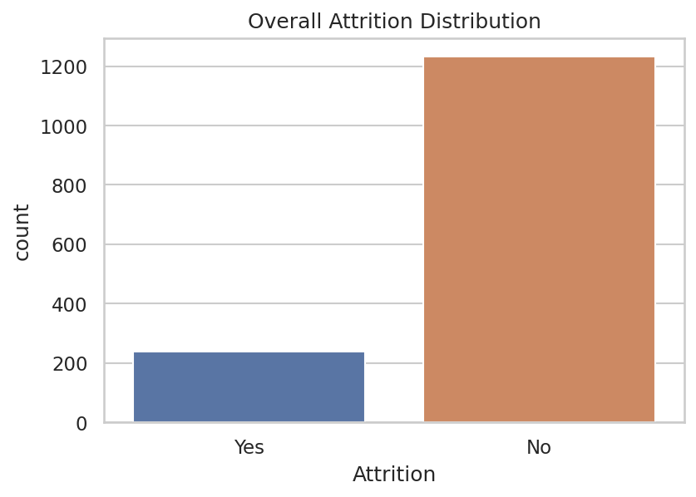
Figure 1: Overall attrition distribution across the workforce.
Approximately 16% of employees in the dataset left the company (Attrition = Yes), while 84% remained. This class imbalance is an important consideration in model evaluation.

3.2 Age Distribution by Attrition
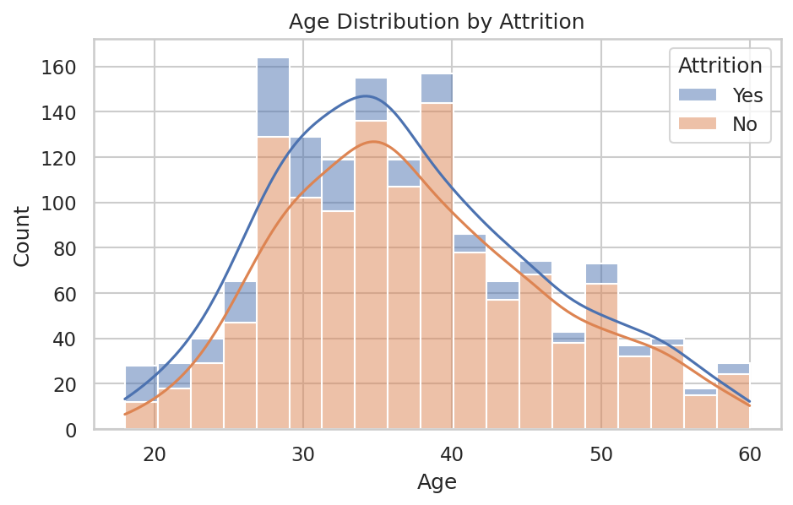
Figure 2: Age distribution split by attrition status.
Younger employees, particularly those under 35, show a higher tendency to leave than older, more established employees.

3.3 Attrition by Department
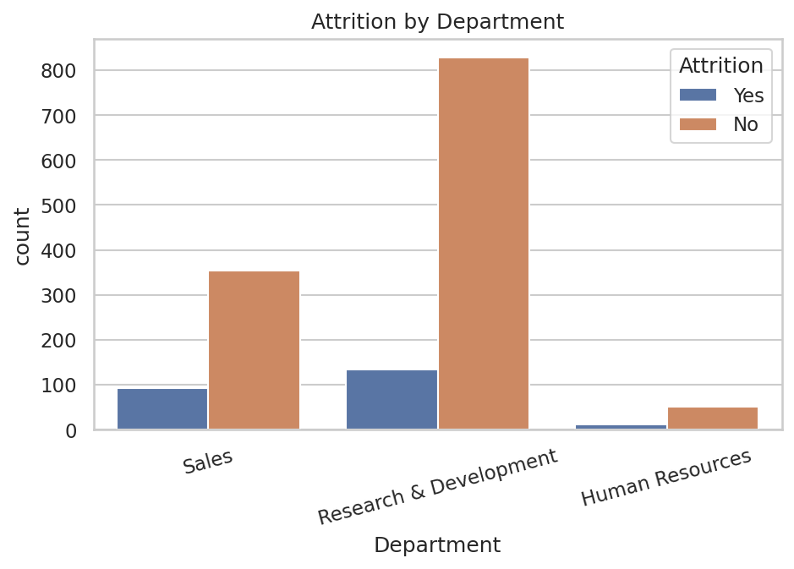
Figure 3: Attrition counts by department.

3.4 Attrition by Job Role
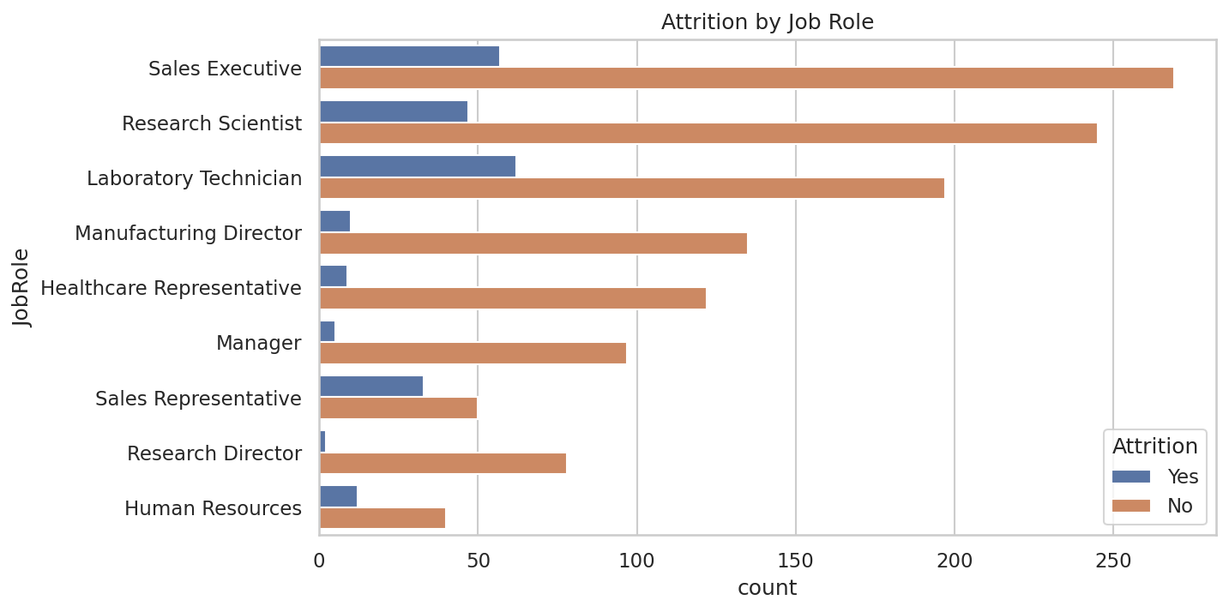
Figure 4: Attrition counts by job role.
Sales Representatives and Laboratory Technicians show higher attrition proportions relative to their department size compared to roles such as Research Director or Manager.

3.5 Attrition by OverTime Status
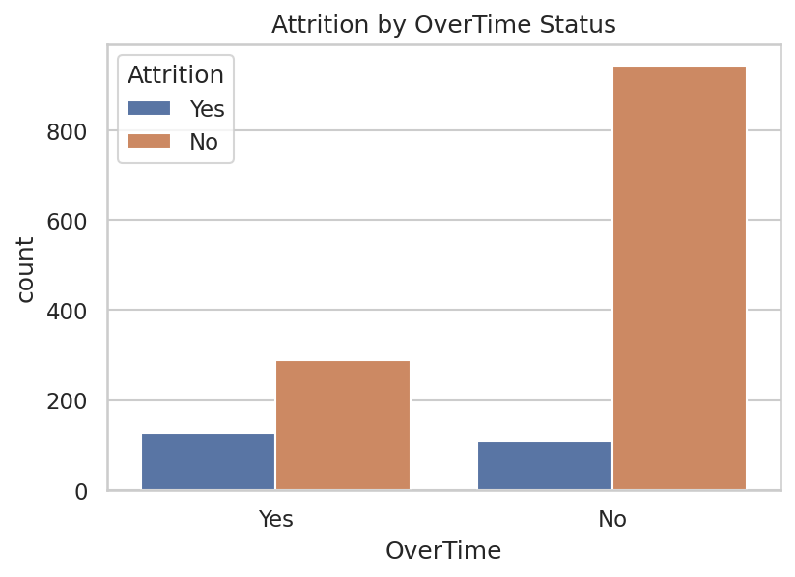
Figure 5: Attrition by overtime status.
Employees who regularly work overtime leave at a substantially higher rate than those who do not, making overtime one of the strongest observed behavioral indicators of attrition risk.

3.6 Monthly Income vs Attrition
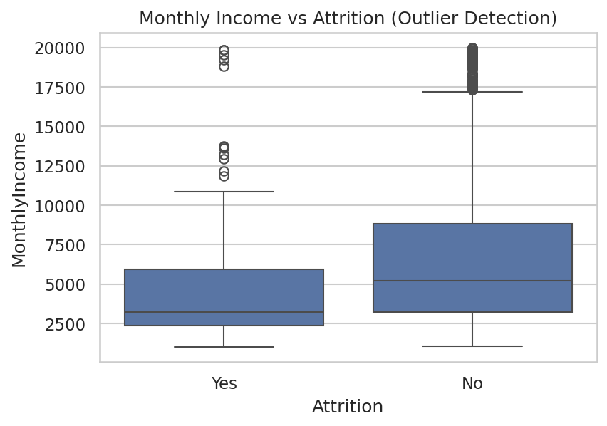
Figure 6: Monthly income distribution by attrition status, used for outlier detection.
Employees who leave tend to have a lower median monthly income. A number of high-income outliers are present but correspond to legitimate senior, long-tenured employees rather than data errors.

3.7 Correlation Heatmap
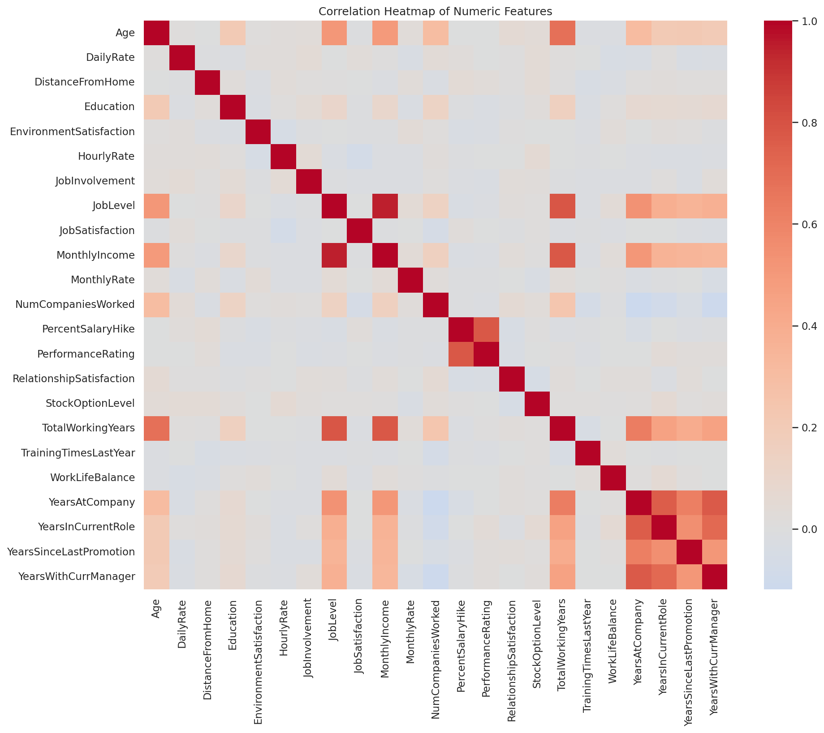
Figure 7: Correlation heatmap of numeric features.
Tenure-related features (YearsAtCompany, YearsInCurrentRole, YearsWithCurrManager, TotalWorkingYears) are strongly correlated with one another, reflecting overall employee tenure as a common underlying factor.

3.8 Attrition by Gender and Work-Life Balance
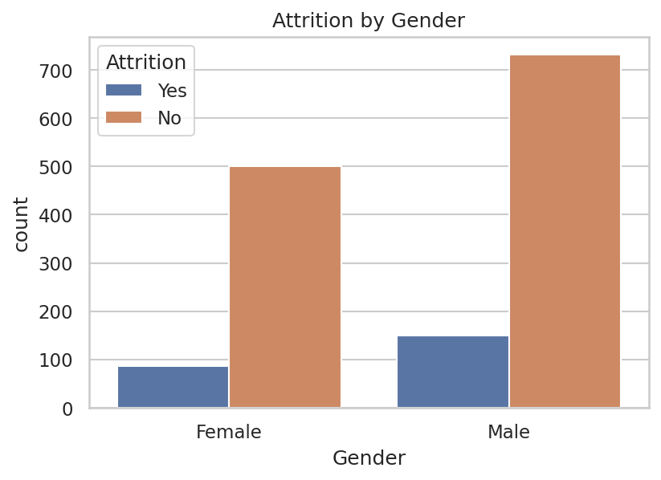
Figure 8: Attrition by gender.
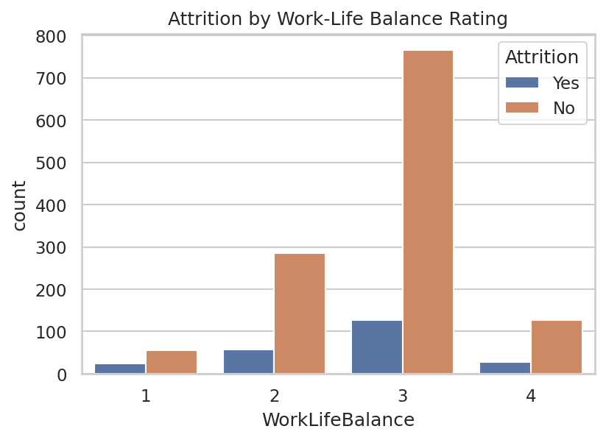
Figure 9: Attrition by work-life balance rating.

3.9 Distance From Home
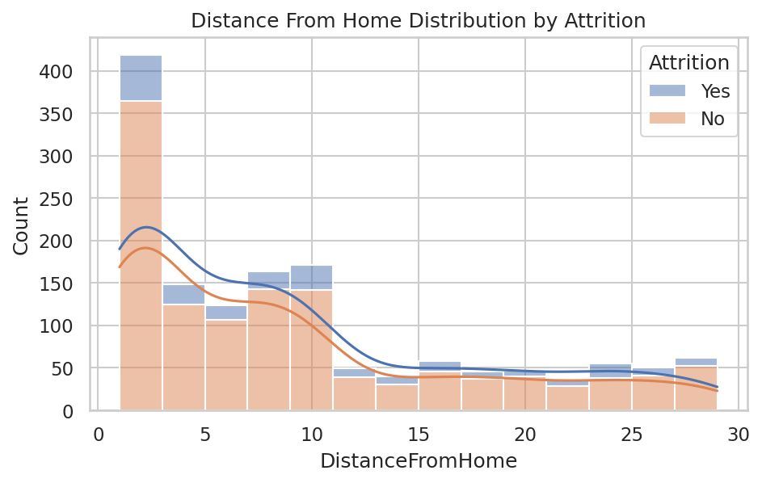
Figure 10: Distance from home distribution by attrition status.
Employees who commute farther from home show a modestly elevated attrition rate, though the effect is smaller than overtime or income.

4. Machine Learning Model
All categorical variables were label-encoded and the target variable (Attrition) mapped to a binary label (Yes = 1, No = 0). The data was split into training (80%) and testing (20%) sets using stratified sampling to preserve class balance. Features were standardized for the Logistic Regression model.
Three classification models were trained and evaluated: Logistic Regression, Decision Tree, and Random Forest.

4.1 Model Performance Comparison
Model | Accuracy | Precision | Recall | F1-Score
Logistic Regression | 0.874 | 0.692 | 0.383 | 0.493
Decision Tree | 0.782 | 0.319 | 0.319 | 0.319
Random Forest | 0.844 | 0.545 | 0.128 | 0.207

Logistic Regression achieved the strongest F1-score for the minority (attrition = Yes) class, offering the best balance between precision and recall. While Random Forest attained comparable accuracy, its low recall means it misses a large share of employees who actually leave — a costlier error from an HR retention standpoint. F1-score on the attrition class was therefore used as the primary model-selection criterion rather than raw accuracy, given the class imbalance in the dataset.

4.2 Confusion Matrices
- Logistic Regression — True Negatives: 239, False Positives: 8, False Negatives: 29, True Positives: 18
- Decision Tree — True Negatives: 215, False Positives: 32, False Negatives: 32, True Positives: 15
- Random Forest — True Negatives: 242, False Positives: 5, False Negatives: 41, True Positives: 6

5. Model Improvement & Presentation

5.1 Hyperparameter Tuning
Logistic Regression was selected as the best-performing model and tuned using GridSearchCV with 5-fold cross-validation, optimizing for F1-score. The search covered the regularization strength C and solver type.
- Best parameters found: C = 10, solver = lbfgs
- Tuned model performance: Accuracy 0.874, Precision 0.692, Recall 0.383, F1-Score 0.493
The tuned model's performance matched the default configuration on this dataset, indicating the default Logistic Regression hyperparameters were already close to optimal for this feature set.

5.2 Feature Importance
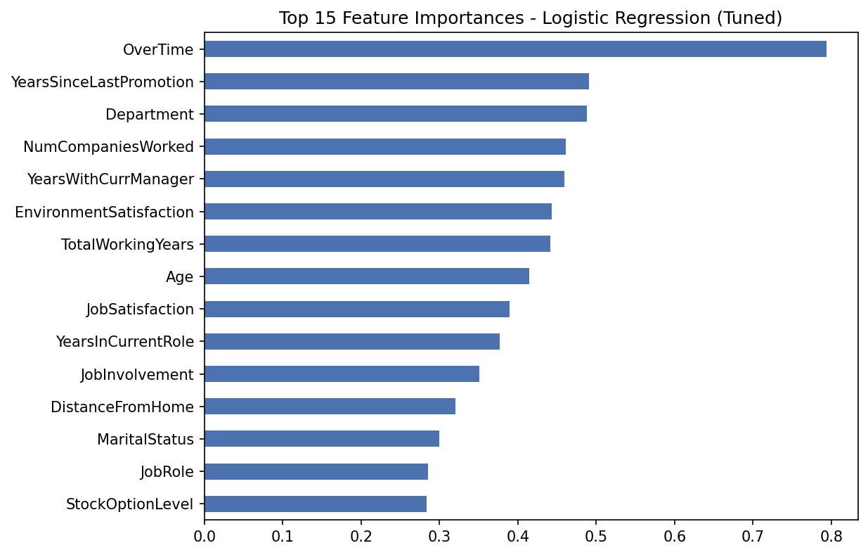
Figure 11: Top 15 feature importances based on Logistic Regression coefficient magnitude.
OverTime, YearsSinceLastPromotion, Department, NumCompaniesWorked, and YearsWithCurrManager are the strongest predictors of attrition. This aligns with the EDA findings that overtime and career stagnation (lack of promotion or manager change) are major drivers of turnover.

6. Business Recommendations
- Manage overtime carefully — employees who regularly work overtime leave at a much higher rate. Review workload distribution and staffing levels in high-overtime teams.
- Address career stagnation — long time since last promotion is a top predictor of attrition. Establish clearer promotion timelines and career-growth conversations.
- Review compensation for at-risk roles — Sales Representatives and Laboratory Technicians show higher attrition; benchmark their pay against market rates.
- Support early-career and early-tenure employees — younger employees and those in their first few years show higher attrition; structured onboarding and mentorship programs may help.
- Monitor job and environment satisfaction scores — these self-reported metrics are meaningfully associated with attrition and can serve as an early warning signal in regular employee surveys.

7. Conclusion
This project analyzed the IBM HR Analytics Employee Attrition dataset end-to-end, from data cleaning and exploratory analysis through model training, comparison, and tuning. The tuned Logistic Regression model provides an interpretable baseline for identifying employees at risk of attrition, and the feature importance analysis highlights actionable levers — overtime, promotion cadence, compensation, and tenure — that HR can use to reduce turnover.

8. Deliverables
- Cleaned dataset (data/processed/cleaned_attrition_data.csv)
- Jupyter Notebook with full analysis (notebooks/attrition_analysis.ipynb)
- Data visualization charts (charts/)
- Trained machine learning model (models/attrition_model.pkl)
- Performance evaluation report (report/model_performance.json)
- Interactive Streamlit app for attrition prediction and HR insights (app/app.py)
- HR business insights and recommendations (this document)
- Modular pipeline scripts for preprocessing, EDA, and model training (scripts/)

